2.
#include<stdio.h>
int main()
{
int i,j;
for(i=1;i<=5;i++){
for (j=1;j<=i;j++){
if(j%2==0){
printf("%d",j*j);
}else{
printf("%d",j*j*j);
}
}
printf("\n");
}
}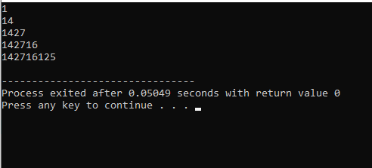

3.
#include<stdio.h>
int main()
{
int i,j;
for(i=1;i<=5;i++){
for (j=1;j<=i;j++){
printf("%d",i);
}
printf("\n");
}
}
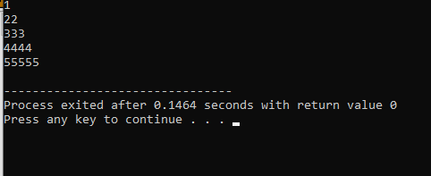

4.
#include<stdio.h>
int main()
{
int i,j;
for(i=5;i>=1;i--){
for (j=1;j<=i;j++){
printf("%d",j);
}
printf("\n");
}
}
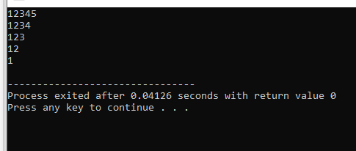

1. #include<stdio.h>
int main()
{
float shop[5][2];
float total;
float grandtotal=0;

printf("enter quantity and price of 5 products\n");
for(int i=0;i<5;i++){
printf("%d price", i+1);
scanf("%f %f",&shop[i][0],&shop[i][1]);
}
for(int i=0;i<5;i++){
total=shop[i][0]*shop[i][1];
grandtotal=+total;
printf("%d %.0f %.2f %.2f\n", i+1,shop[i][0],shop[i][1],total);
}
printf("grand total=%.2f\n", grandtotal);
}
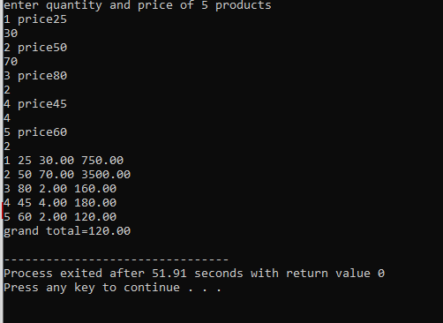
Important task: